Lapiz Lazuli

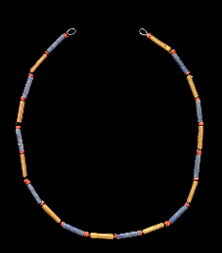
Necklace of Queen Puabi; Gold, carnelian and lapiz lazuli; Early Dynastic III, Findspot: Ur, Iraq; 3rd millenium BCE; The British Museum (1929,1017.237)

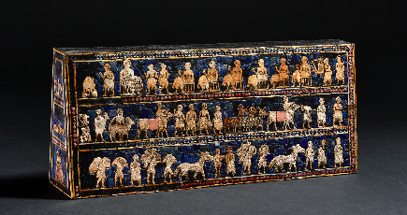
Peace side — ‘Standard of Ur’ (replica); Wood, shell, limestone, lapis lazuli, bitumen, inlaid; Findspot: Royal Cemetery at Ur, Iraq; 2500 BCE; The British Museum (replica of 121201)

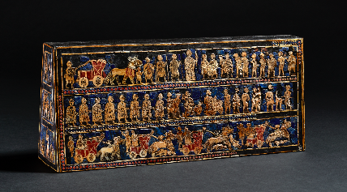

War side — ‘Standard of Ur’ (replica); Wood, shell, limestone, lapis lazuli, bitumen, inlaid; Findspot: Royal Cemetery at Ur, Iraq; 2500 BCE; The British Museum (replica of 121201)

